Analyzing Heart Rate Variability Following an Acute Resistance Training Session
Jeeva Gill (T00626850)
Thompson Rivers University
Dr. Mark Rakobowchuk
BIOL 3550_L03 - Human Physiology 2
April. 29th, 2022

Abstract:

Resistance Training has become a popular method for people to perform physical activity to achieve certain physical qualities. Throughout resistance training, an individual’s body has to undergo physiological changes to keep functioning at a high level. Heart rate variability (HRV) is a non-invasive and useful method by which to monitor autonomic activity, during a resistance training session. HRV is found to be linked with the baroreflex system which functions to inform the autonomic nervous system of beat-to-beat changes in heart rate and blood pressure. The goal of this study was to determine how HRV was affected during acute resistance training to see if there was a significant difference in autonomic output during the recovery time following an acute resistance training session, using four different HRV metrics: SDNN, HF, SD2, and Sample Entropy. Ten healthy individuals were recruited to participate in the study. The participants HRV was monitored under two different conditions, a control day and acute resistance training day. Their HRV was obtained at three different time periods: before the exercise (“Pre”), immediately after exercise (“Immediately Post”), and 1 hour after exercise (“Post 1 Hour”). An ANOVA 2-way within subject repeat test was performed using the HRV metrics. Through statistical analysis, it was found that parasympathetic activity increased immediately following resistance training. These results indicated that HRV increases, due to an increase in parasympathetic activity, to help an individual recover from a resistance training session. Furthermore, it demonstrates the resistance training can be beneficial to increase parasympathetic activity help modulate blood pressure in order to allow an individual to be able to recover better.

Intro:
Resistance training has gained popularity in the last decade and today, it is widely used by recreationally active individuals to enhance their physical qualities. An individual needs to undergo physiological adaptations in the autonomic nervous system throughout the training session to not only achieve training and performing goals, but also to help in the recovery process after the training has finished (Marasingha-Arachchige et. al, 2020). Heart rate variability (HRV) has been considered to be a useful method by which to monitor autonomic activity, during a resistance training session (Michael et. al, 2017). Heart rate variability refers to the changes in the time intervals between heart beats. In healthy individuals, the intervals between heartbeats are constantly changing and being adjusted to maintain blood pressure. Heart rate variability is used to assess autonomic nervous system activity by measuring the changes in the cardiac rhythm through time (Mejía-Mejía et. al, 2020). Cardiac activity is controlled by both the sympathetic and parasympathetic systems, which induce heart rate oscillations at different rhythms. The sympathetic nervous system prepares the body for energy expenditure, emergency, or stressful situations in response to high stimuli. Once the high stimuli have passed, the parasympathetic nervous system counteracts the sympathetic nervous system and brings the body back to a restful state by decreasing heart rate and increasing the body's normal operations, such as digestion (Gordan et. al, 2015). HRV information is usually measured using an electrocardiographic signal (ECG) to obtain the R-R intervals, the duration between each consecutive QRS complex peak (Pichot et. al, 2016). There are multiple indices that can be used to measure HRV, including SDNN, HF, SD2, and Sample Entropy.
SDNN is the standard deviation of the NN intervals, that is, the square root of variance calculated over short periods of time (Task Force of European Society of Cardiology, 1996; Shaffer and Ginsberg, 2017). It measures the effect of both the parasympathetic and sympathetic nervous systems, as it observes fluctuations between the two (Shaffer & Ginsberg, 2017).
The HF reflects parasympathetic activity and is called the respiratory band because it corresponds to the HR variations related to the respiratory cycle (Mejía-Mejía et. al, 2020; Shaffer and Ginsberg, 2017). It is a measurement made in absolute values of power, ms² (Task Force of European Society of Cardiology, 1996). The efferent vagal activity is a major contributor to the HF component, and it is thought to reflect an increase in parasympathetic nervous system activity (Task Force of European Society of Cardiology, 1996; Shaffer & Ginsberg, 2017). In this study, we observed absolute power values of HF.
SD2 is considered the standard deviation of the non-linear measurement of long-term heart rate variability (Shaffer and Ginsberg, 2017). It reflects the dispersion of the points along the line of identity (Mejía-Mejía et. al, 2020). SD2 is highly influenced by parasympathetic activity and correlates with baroreflex sensitivity (Shaffer & Ginsberg, 2017).
Sample entropy is used to describe the regularity or randomness of the dataset of HRV (Mayer et. al, 2014).
The impacts of HRV occurs through the stimulation of respiratory and autonomic reflexes, such as the baroreflexes, which lead to improved baroreflex function as well as increased gas exchange efficiency (Steffen et. al, 2021). The baroreflex system acts as a negative feedback loop to help stabilize certain processes, such as heart rate. This system produces periodic fluctuations in blood pressure, heart rate, and vascular tone that reflect modulatory control (Lehrer and Eddie, 2014). When the body is subjected to stressors, like acute resistance training, the heart rate may accelerate. To counteract this, the baroreflex system uses baroreceptors that function to inform the autonomic nervous system of beat-to-beat changes in heart rate and blood pressure (Dimitriev et. al, 2016). When there is an increase in stretch, this is sensed by the baroreceptors, and parasympathetic output will increase via the vagus nerve, whereas sympathetic output will decrease in the peripheral blood vessels, decreasing vascular resistance, lowering blood pressure. This causes the R-R intervals to increase in length, changing the heart rate (Dimitriev et. al, 2016; Ernst, 2017). Both autonomic responses combine to counteract increases in blood pressure.
In this study, we investigated the effects of HRV in 10 individuals at three different time periods (Pre exercise, Immediately Post exercise, and Post 1 hour exercise) and in two different conditions (Control and Resistance Exercise) to see if there was a significant difference in autonomic output during the recovery time following an acute resistance training session.

Methods:
Participants
Ten healthy participants (5 male and 5 female) who participated in regular exercise at least 3 times a week were recruited to participate in the study. Participants were excluded from the study if they were pregnant, regular smokers, taking medication other than the contraceptive pill, under the age of 19 or 35, or had an underlying cardiovascular illness or a history of cardiovascular disease. Written consent was obtained from all ten participants in regard to the risks associated with the study. The procedures and risks of this study were reviewed and approved by the Research Ethic Board of Thompson Rivers University.

Study Design
Participants came to the laboratory on three separate occasions throughout the conduction of the study. For 24 hours prior to each of the three testing days, participants were asked to refrain from performing strenuous exercise and consuming alcohol. On the day of testing, participants were asked to refrain from consuming caffeine. Upon arriving to the lab, participants were asked to rest quietly in a supine position for 10 minutes before the testing began.

Experimental Protocol
On the first day of testing, baseline measurements of R-R intervals were obtained at three separate time intervals (0 minutes, 45 minutes post, and 105 minutes post). These values acted as control measures for the pre workout, immediately post workout, and 1 hour post workout measurements that would be obtained on the testing day where resistance exercise training occurred. R-R intervals were recorded using three lead electrocardiogram (ECG) that were placed on the left and right clavicle of the participant as well as the left hip. The data was recorded on a computer using the software AcqKnowledge. The R-R interval data was recorded throughout the entire session, which included the rest period before and after the Valsalva manoeuvre was performed as well as when the Valsalva was being performed. On the second day of testing, participants conducted a series of tests according to standard guidelines obtained from the National Strength and Conditioning Association to determine their 10-rep maximum for the exercises used in the resistance exercise training. The exercises performed by each of the participants were as follows: Bicep curl, Triceps Extension, Lat Pull Down, Bent-over Row, Leg extension, Leg curl and Leg Press. For the upper body portion, only the right arm was used by the participants as on the day of testing, blood pressure would be monitored using their left arm. On the third day of testing, participants conducted a 45-minute, maximal resistance training workout. Testing began at the same time at which their baseline testing occurred. Participants completed 3 sets of 10 repetitions at their 10-rep maximum weight for each respective exercise. Between sets participants were a 2-minute rest. Throughout the workout, continuous beat-by-beat arterial BP and heart rate (HR) to determine the workload placed on the body.

Obtaining HRV metrics
Once all the data had been collected for both the control day and the resistance exercise day, we were able to analyze the HRV. All files that recorded the ECG data from each participant was converted to from and AcqKnowledge file to a LabChart file. From there, two different macros were created to analyze the data needed. Firstly, a macro was created on LabChart that recorded heart rate variability of an individual rest period that lasted two and a half minutes after the participant initiated a Valsalva for 15 seconds. The macro recorded the local maximum of the QRS complex of each individual R-R interval, using a 5% threshold. Then, a second macro was recorded by incorporating the first macro, to read the entire LabChart file and record heart rate variability data for six different rest periods that lasted two and a half minutes in length. The data collected was then input into the data pad on LabChart. Once the macros were created for the first participant, we were able to import them into all the other files for the different testing days and times for each individual participant and also among the different participants. The macros used were the same for the control and resistance exercise data. The raw data was then graphed using Microsoft Excel 2016 to see if there were any data points that were outliers. If so, the individual point(s) were then located in the LabChart file, and the correct number was inputted into the data pad in Microsoft Excel. The individual data sets for each participant that were obtained then had to be “unstacked”, meaning that each individual 2-and-a-half-minute rest period after the Valsalva was performed (6 in total for each data set) had to move to its own sheet. Each individual Microsoft Excel sheet was then saved as a text file and inputted into the HRVanalysis software. This software was able to calculate used to analyze heart rate variability. The values corresponding to SDNN, HF, SD2, and Sample Entropy were collected and placed into a separate Microsoft Excel spreadsheet for each participant. The six different rest periods were then averaged, giving us a mean for the four different HRV metrics. This process of collecting values to analyze HRV from the HRVanalysis software was done for each participant during the three different time periods the Valsalvas were conducted as well as the two different conditions (control and resistance exercise).

Statistical Analysis
Once all the different values for SDNN, HF, SD2, and Sample Entropy were collected for each participant, under the two different conditions, the data was compiled into a single Microsoft Excel spreadsheet. Using the free open-source software statical program, Jasp, an ANOVA 2-way within subject repeat test was performed. Differences between the two different condition (Control and Resistance) factors along with the three different time period (Pre, Immediate Post, 1 Hour post) factors were calculated. The interaction between condition and time was also analyzed using an ANOVA 2-way within subject repeat test in Jasp. A Post Hoc Comparison was performed on the factors that were significantly different. The Post Hoc Comparison test used was Tukey’s Test. It was testing differences among the different time and condition possibilities for significance. If the interaction between condition and time was significant, a Post Hoc comparison was only performed for that, even if a different individual factor (either time or condition) also showed significant difference. For significant differences, we only observed those between different time periods of the same condition and the same time period in the different conditions. The ANOVA 2-way within subject repeat test in Jasp also gave the means for each of the four different HRV metrics at the three different time periods in each of the two conditions. These means were the graphed using Microsoft Excel to demonstrate the distribution.

Results:
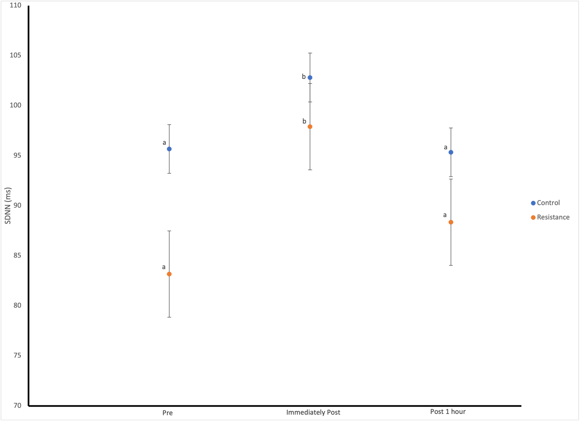
Figure 1. Means of SDNN values for all participants at the three different time periods and the two different conditions (N=10). The means denoted with different letters (a; b) indicate significant differences between time periods within the same condition.

Figure 1 shows that the mean for SDNN for the time period indicated as “Immediately Post” was significantly different from the other two time periods, “Pre” and “Post 1 hour” in the same condition. This can be seen in both the control and resistance conditions.

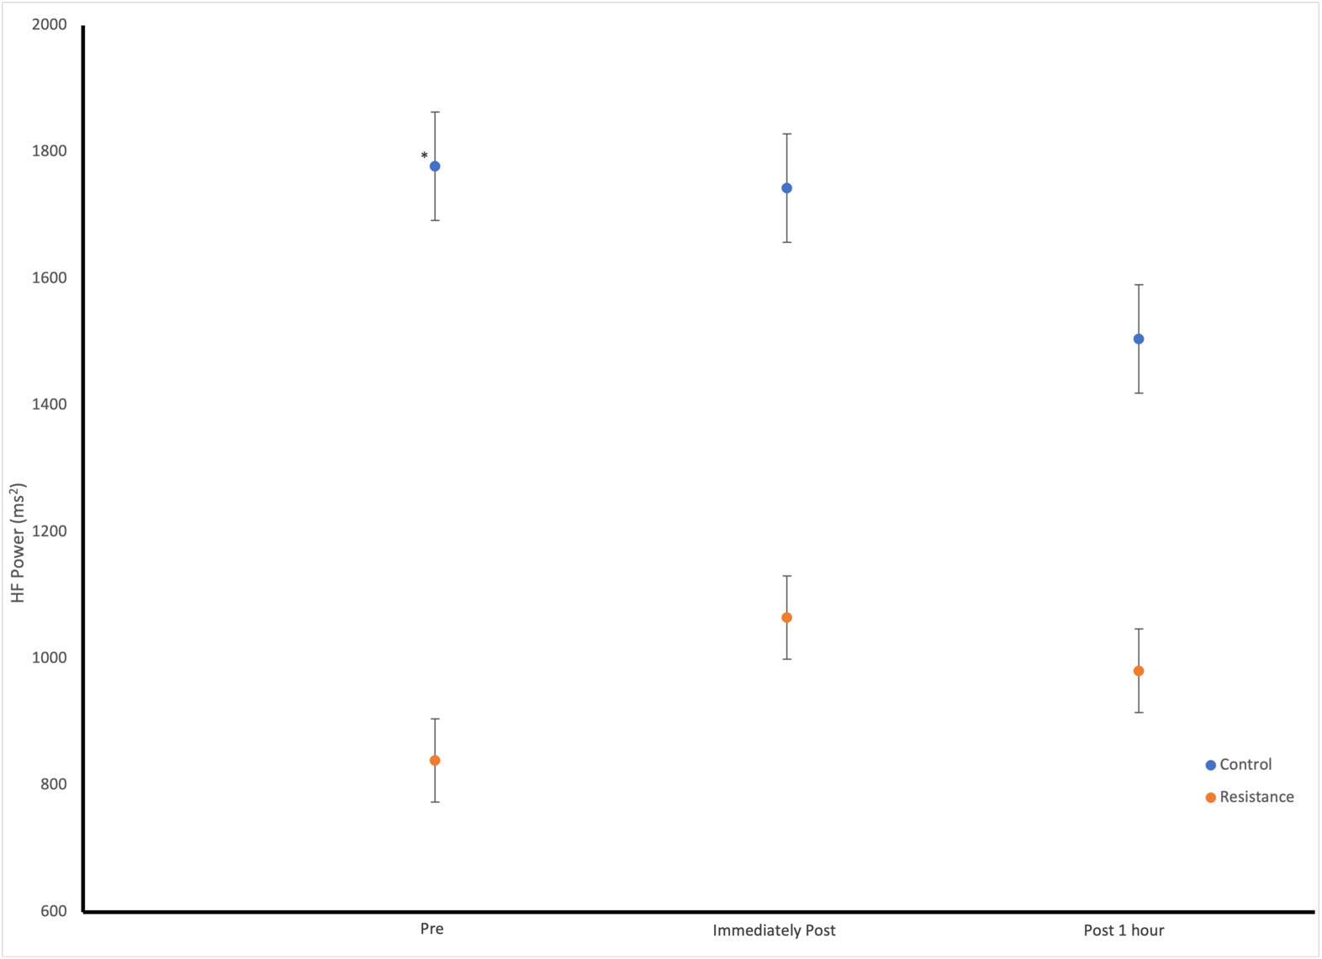
Figure 2. Means of HF Power values for all participants at the three different time periods and the two different conditions (N=10). The means denoted with the asterisks (*) indicate significant differences between the two conditions at the same time period.

Figure 2 shows that the means for HF at the time period, “Pre”, were significantly different when comparing the two conditions (Control and Resistance). The other time periods did not differ between conditions.

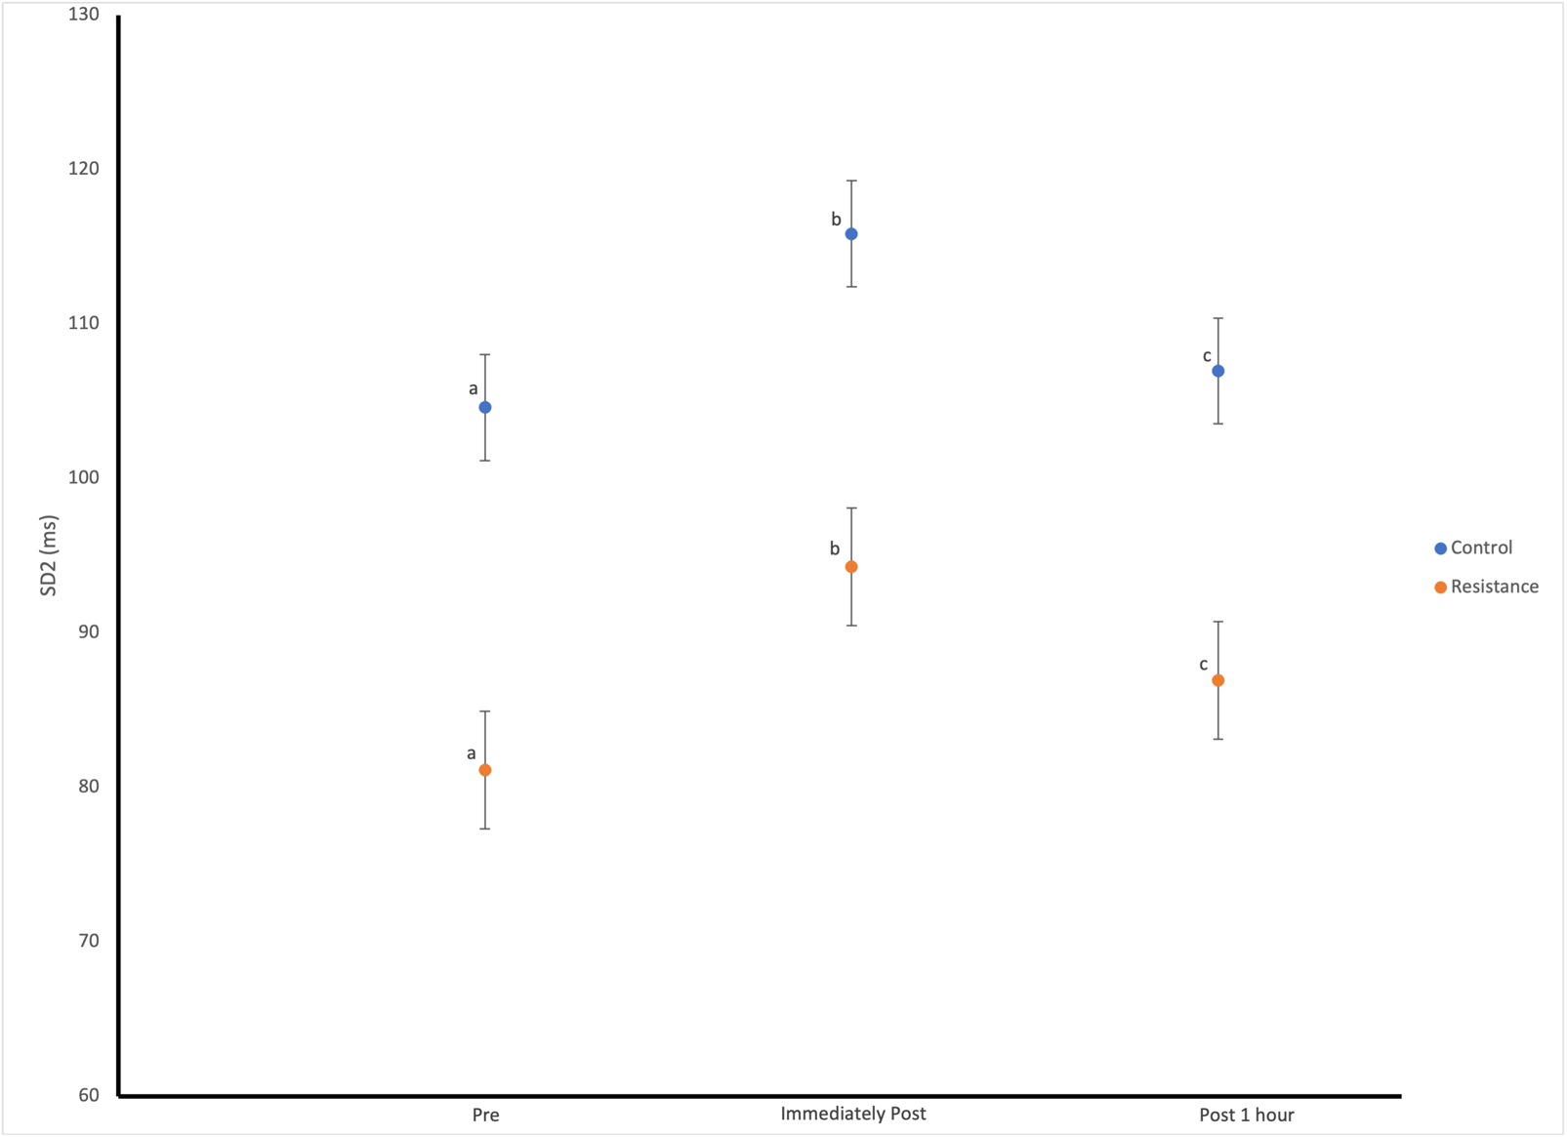
Figure 3. Means of SD2 values for all participants at the three different time periods and the two different conditions (N=10). The means denoted with different letters (a; b; c) indicate significant differences between time periods within the same condition.

Figure 3 shows that the mean for SD2 for all three time periods (Pre, Immediately Post, and Post 1 hour) were all significantly different from one another. When comparing the different conditions (Control and Resistance) at the three different time periods, there was no significant difference.

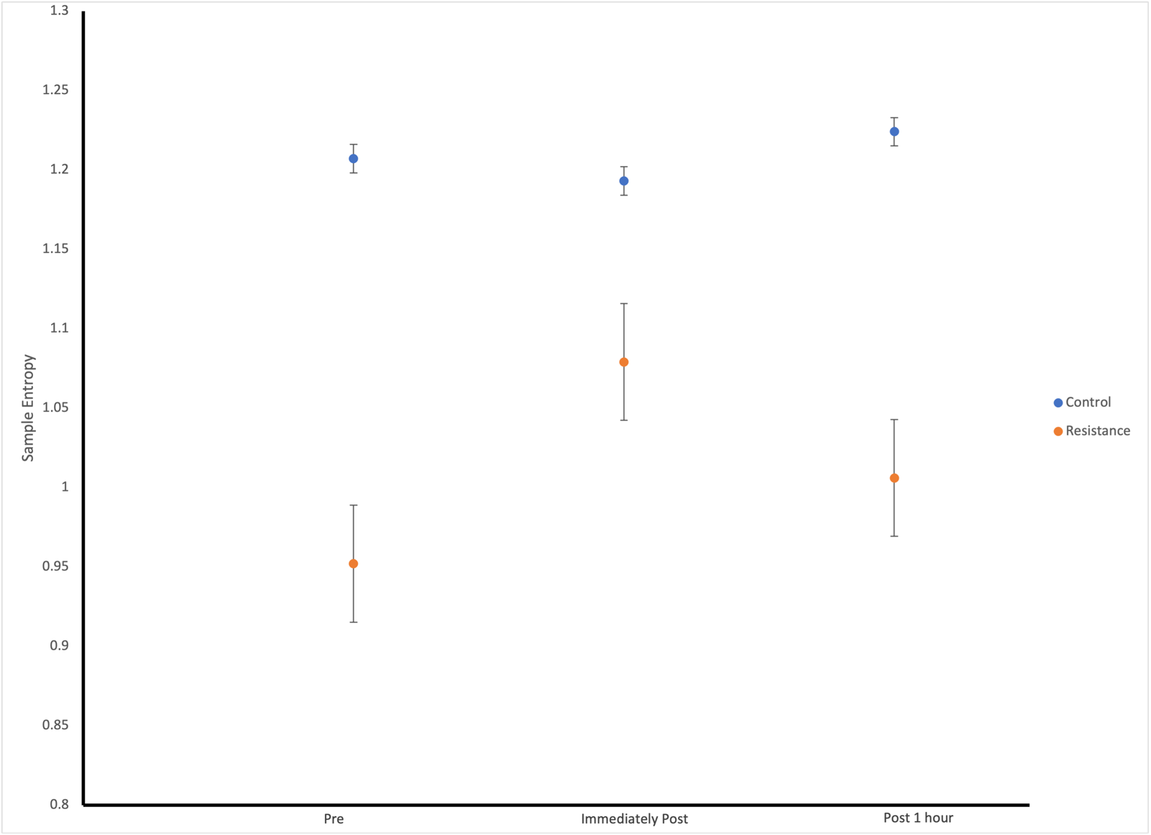
Figure 4. Means of sample entropy values for all participants at the three different time periods and the two different conditions (N=10).

Figure 4 shows that there was a significant difference between the two conditions (Control and Resistance) in regard to sample entropy.

Discussion:
This study looked at if heart rate variability (HRV) was affected during acute resistance training performed by 10 healthy participants. HRV has been commonly applied to athletes in order to control working load doses during training periods (Estévez-González et. al, 2021). It has been used as a non-invasive method to evaluate heart rate regulation caused by autonomic nervous system activation, and more specifically, the subdivisions known as the parasympathetic and sympathetic nervous systems (Mejía-Mejía et. al, 2020; Kingsley and Figueroa, 2014).
In terms of the different metrics that can be used to analyze HRV, SDNN can be used to observe the differences in both sympathetic and parasympathetic activity. It is also thought that the main source of variation in short-term recordings is the parasympathetically mediated respiratory sinus arrhythmia (RSA) (Mejía-Mejía et. al, 2020; Shaffer and Ginsberg, 2017). RSA is considered to be a marker of vagal (parasympathetic) function and can be used as an index in the measurement of the heart’s vagal control (Shaffer & Ginsberg, 2017). When observing the results of SDNN, the interaction between the two factors (condition and time) was significant (p < 0.05). We were able to see that in both the control condition as well as the resistance exercise condition, there was a significant increase in the mean during the time period “Immediately Post”. This indicates that parasympathetic activity was high immediately following exercise. As the participants began to return to their normal resting rates, the parasympathetic activity decreased, as did the SDNN mean values.
When looking at the results of SD2, the time factor was significant (p < 0.05). It can be seen that each of the three time periods significantly differs from one another. The time period “Immediately Post” had the highest SD2 value for both conditions (Control and Resistance). The increase during the immediately post time period indicates an increase in parasympathetic activity and then as the participant is recovering, their parasympathetic activity decreases and begins to return to a resting level.
In regard to HF, the p-value for the interaction between the condition and time factors was significant (p < 0.05). The HF values only differed significantly between the two conditions (Control and Resistance) at the time period “Pre”. This difference was unexpected as they should have been relatively similar. The difference did not really inform us about the magnitude of activation in autonomic activity in regard to acute resistance training. Overall, these results indicate that there was no real change in parasympathetic activity during any of the three time periods. This finding aligns with a study conducted by Figueroa et. al in 2007, where they found that absolute power HF (ms²) did not improve after a resistance training session. However, in different studies, when observing the HFnu (nu = normalized units), it was seen that HFnu significantly increased following resistance exercise training and then began to significantly decrease as the individual was recovering (Marasingha-Arachchige et. al, 2020; Michael et. al, 2017).
In regard to sample entropy, there was significant differences found between conditions (p < 0.05). The control condition had a higher sample entropy compared to the resistance condition. This indicates that vagal HR modulation was greater in the control condition (Weippert et. al, 2014). From a study conducted by Porta et. al in 2013, concluded that a change in sympathetic-vagal balance towards a sympathetic dominance increased regularity and thus reduced entropy values.
HRV reflects regulation of autonomic balance, blood pressure (BP), gas exchange, gut, heart, and vascular tone (Dias et. al, 2021). Having an optimal level of HRV is associated with health and self-regulatory capacity, and adaptability or resilience (Shaffer & Ginsberg, 2017). After observing the different HRV metrics, one could see that there was an increase in parasympathetic activity that occurred immediately after a resistance training session. This indicates that HRV was affected immediately after acute resistance exercise, especially when there was an increase of parasympathetic activity to help with recovery as rapid (though incomplete) recovery is commonly observed in the initial minutes following exercise (Michael et. al, 2017). As participants began to recover, the slowed rate of breathing in turn can contribute to an increased baroreflex sensitivity, leading to a more regular HR pattern and an elevation of baroreceptor mediated HRV measures (Weippert et. al, 2014). Having higher HRV metrics and therefore having higher variability indicated good health conditions in individuals and provide a good measure of the adaptivity of the brain–body system (Ernst, 2017). A review, conducted by Kingsley and Figueroa in 2014, found that studies suggest that acute resistance training may not improve resting HRV in healthy young adults overall because they already have a normal cardiac autonomic function. However, it is possible that beneﬁcial effects of resistance training on HRV may be observed during recovery from exercise.
The findings from this study indicate the resistance training is an effective way to increase parasympathetic activity immediately following exercise to modulate blood pressure in healthy individuals so they are able to recover better after a training session.

Limitations:
The metric HF that was used to analyze HRV showed that there was no significant difference in the time periods of the different conditions. This could potentially be due to the fact that HF used in the statistical analysis was the absolute power of HF (ms²), instead of normalized units of HF (HFnu). This could have affected how parasympathetic activity, in terms of HF values, changed during acute resistance exercise training. Individual heart rate was also not part of the data that was collected and analyzed. The heart rate of the participants could have also been an indicator as to whether or not autonomic output was increased during the recovery period.

Literature Cited:
Dias RM, Moraes ÍAP, Dantas MTAP, Fernani DCGL, Fontes AMGG, Silveira AC, Barnabé V, Fernandes M, Martinelli PM, Monteiro CBM, Garner DM, Abreu LC, Silva TD. (2021). Influence of Chronic Exposure to Exercise on Heart Rate Variability in Children and Adolescents Affected by Obesity: A Systematic Review and Meta-Analysis. International Journal of Environmental Research and Public Health. 18(21):11065. https://doi.org/10.3390/ijerph182111065
Dimitriev, D. A., Saperova, E. V., & Dimitriev, A. D. (2016). State Anxiety and Nonlinear Dynamics of Heart Rate Variability in Students. Plos One, 11(1). doi:10.1371/journal.pone.0146131
Ernst G. (2017). Heart-Rate Variability-More than Heart Beats?. Frontiers in public health, 5, 240. https://doi.org/10.3389/fpubh.2017.00240
Estévez-González AJ, Donadio MVF, Cobo-Vicente F, Fernández-Luna Á, Sanz-Santiago V, Villa Asensi JR, Iturriaga Ramirez T, Fernández-del-Valle M, Diez-Vega I, Larumbe-Zabala E and Pérez-Ruiz M. (2021). Effects of a Short-Term Resistance-Training Program on Heart Rate Variability in Children With Cystic Fibrosis—A Randomized Controlled Trial. Front. Physiol. 12:652029. doi: 10.3389/fphys.2021.652029
Figueroa A, Baynard T, Fernhall B, Carhart R,Kanaley JA. (2007). Endurance training improvespost-exercise cardiac autonomic modulationin obese women with and without type 2 dia-betes. Eur J Appl Physiol.
Gordan, R., Gwathmey, J. K., & Xie, L. (2015). Autonomic and endocrine control of cardiovascular function. World Journal of Cardiology, 7(4), 204. doi:10.4330/wjc.v7.i4.204
Kingsley, J. & Figueroa, Arturo. (2014). Acute and training effects of resistance exercise on heart rate variability. Clinical physiology and functional imaging. 36. 10.1111/cpf.12223.
Lehrer, P., & Eddie, D. (2013). Dynamic Processes in Regulation and Some Implications for Biofeedback and Biobehavioral Interventions. Applied Psychophysiology and Biofeedback, 38(2), 143-155. doi:10.1007/s10484-013-9217-6
Marasingha-Arachchige, S.U., Rubio-Arias, J. Á., Alcaraz, P.E., Chung, L.H., (2020).
Factors that affect heart rate variability following acute resistance exercise: A systematic review and meta-analysis. Journal of Sport and Health Science. ISSN 2095-2546,
https://doi.org/10.1016/j.jshs.2020.11.008.
Mayer, C.C., Bachler, M., Hörtenhuber, M., Stocker, C., Holzinger, A., Wassertheurer, S. (2014). Selection of entropy-measure parameters for knowledge discovery in heart rate variability data. BMC Bioinformatics 15, S2. https://doi.org/10.1186/1471-2105-15-S6-S2.
Mejía-Mejía, E., Budidha, K., Abay, T. Y., May, J. M., & Kyriacou, P. A. (2020). Heart rate variability (HRV) and pulse rate variability (PRV) for the assessment of autonomic responses. Frontiers in Physiology, 11. doi:10.3389/fphys.2020.00779
Michael S., Graham KS., and Davis GM OAM. (2017). Cardiac Autonomic Responses during Exercise and Post-exercise Recovery Using Heart Rate Variability and Systolic Time Intervals—A Review. Front. Physiol. 8:301. doi: 10.3389/fphys.2017.00301
Pichot, V., Roche, F., Celle, S., Barthélémy, J., & Chouchou, F. (2016). HRVanalysis: A free software for analyzing cardiac autonomic activity. Frontiers in Physiology, 7. doi:10.3389/fphys.2016.00557
Porta, A., Castiglioni, P., Bari, V., Bassani, T., Marchi, A., Cividjian, A., Quintin, L., di Rienzo, M. (2013). K-nearest-neighbor conditional entropy approach for the assessment of the short-term complexity of cardiovascular control. Physiol. Meas. 34, 17–33.
Shaffer, F., & Ginsberg, J. P. (2017). An overview of heart rate variability metrics and norms. Frontiers in public health, 5, 258. https://doi.org/10.3389/fpubh.2017.00258
Steffen, P. R., Bartlett, D., Channell, R. M., Jackman, K., Cressman, M., Bills, J., & Pescatello, M. (2021). Integrating breathing techniques into psychotherapy to improve HRV: Which approach is best? Frontiers in Psychology, 12. doi:10.3389/fpsyg.2021.624254
Task Force Of The European Society Of Cardiology The North A Electrophysiology. (1996). Heart rate variability. Circulation, 93(5), 1043-1065. doi:10.1161/01.cir.93.5.1043
Weippert, M., Behrens, M., Fenger, A., & Behrens, Kristin. (2014). Sample Entropy and Traditional Measures of Heart Rate Dynamics Reveal Different Modes of Cardiovascular Control During Low Intensity Exercise. Entropy. 16. 5698-5711. 10.3390/e16115698.

