- Ethical Approval
Ethical approval was granted by the Thompson Rivers University Research Ethics Board
and Biosafety approval was granted by the Thompson Rivers University Biosafety Committee. All participants gave their written and informed consent, both after the experimental procedure and risks had been explained to them and prior to the start of testing.

- Study Participants
Ten healthy participants including 6 males and 4 females between 21 – 23 years of age were recruited to participate in this study. Mean participant age was 21.5 ± STD, height was ADD, and weight was ADD. Recruitment was of Thompson Rivers University Students. Participants were screened prior to testing to ensure they met inclusion criteria. All participants had no blood or platelet/bleeding disorders, and no known cardiac diseases and/or cardiovascular risk factors. None of the participants were hypertensive, smokers, diabetics, or had other known metabolic diseases. The participants were not taking medication or being treated for any disease, did not experience aversion to the sight of blood and/or needles, and were over 19 years of age and under 40 years of age.
Preceding testing, participants were instructed to arrive at the laboratory rested, having refrained from strenuous physical activity, alcohol, marijuana, or non-prescription drug ingestion 24 hours prior to sampling. They were instructed not to cycle or run to and from the laboratory on sampling days, nor partake in any physically demanding work in the hours after the sampling day. Participants were asked to avoid caffeine on the day of sampling before their testing and eating within four hours prior to sampling.

- Experimental Design (Figure 1.)
Participant testing consisted of blood pressure, electrocardiogram (ECG), and ultrasonographic measurements. Upon arrival at the lab, participants were placed in a supine
position in a temperature controlled (21-24°C) room and were instrumented with a noninvasive continuous blood pressure monitor. Once an adequate blood pressure signal was
recording, the participant was left in a supine position for five minutes to ensure baseline sampling was taken at rest, with minimal sympathetic nervous system activation.
Once the rest period was complete, participants underwent a flow mediated dilation (FMD) protocol to measure endothelial dependent dilation of the brachial artery using Doppler ultrasound (described below). Following the FMD, participants underwent a 30-minute exercise bout using a handgrip dynamometer. A second FMD was conducted immediately after the exercise period was complete. The participant was then given a 30-minute rest period where no blood pressure or ECG measurements were taken. Once the 30-minute rest period was complete, participants’ blood pressure and ECG measurements were collected once again and, a third and final FMD was conducted. At the end of testing, participants were given 112, one-gram supplements. The supplements given were either contained white, granulated sugar or table salt. Participants were unaware of which supplements they were given as this information was only known to the individuals on the research team. The decision to give participants either salt or sugar supplements was randomly decided using an online generator. Participants were instructed to intake 16 capsules per day for a seven-day period that began on the day their baseline measurements were gathered. The salt capsules weighed 1.2270g ± 0.018790411. This weight was determined as per previous work by Babcock et. al (2019), as this allowed for 6 grams of sodium to be ingested everyday by the participants for a seven-day period. The sugar capsules were given to participants to act as a placebo and weighed 0.9295g ± 0.01247011. The duration of seven days was also determined per previous work by Babcock et. al, 2019. All participants returned a week after their baseline measurements were taken and they have taken all 112 supplemental capsules. Upon return for post testing, the same procedures described above were repeated. Participants then underwent a “wash-out” period, where they did not ingest any supplements for at least seven-days. After the wash-out period was complete, participants returned to the laboratory and the same procedures described above were repeated to gather their second baseline measurement. After testing was complete, participants were given another 112, one-gram supplements that contained different contents than the one given previously. They were once again instructed to ingest 16 capsules per day for a seven-day period that began on the same day as their second baseline measurements were gathered. Participants then returned to the laboratory for a final time after the seven-day period and the same procedures described above were repeated (Figure 2).

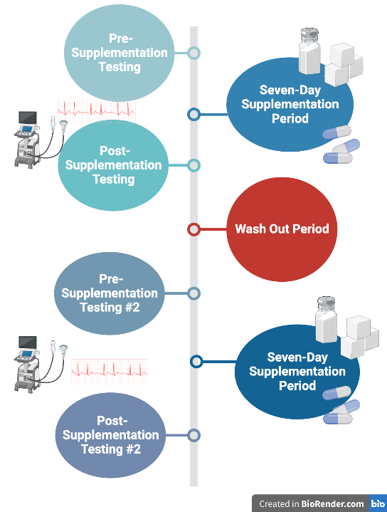

Figure 1. Timeline of experimental procedure.

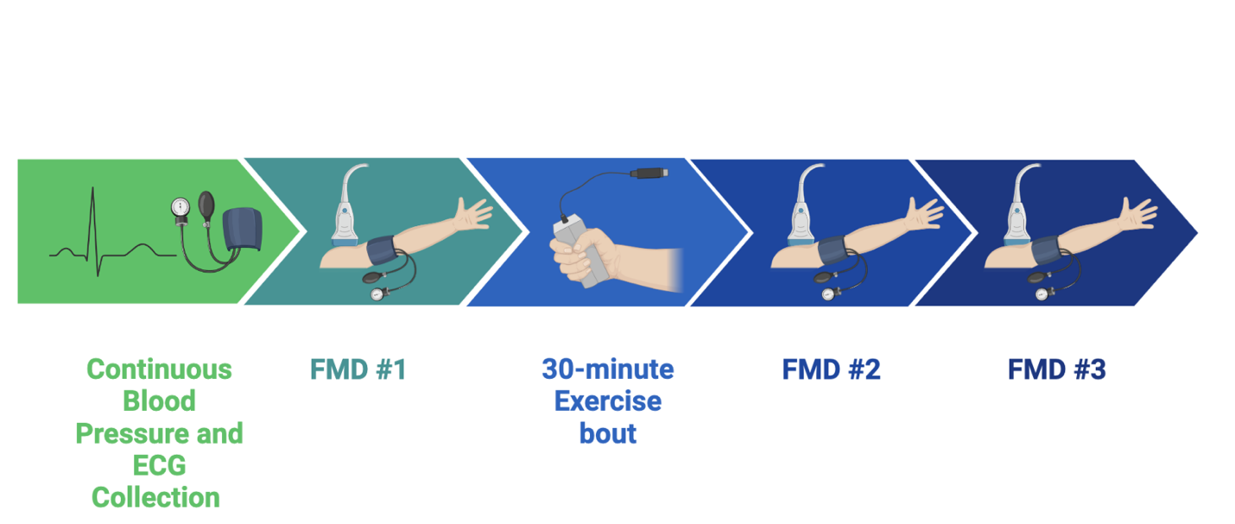
Figure 2. Timeline of test day.

- Hand-grip Exercise
The 30-minute hand-grip exercise was performed using a handgrip dynamometer which was attached to a PowerLab unit. Each participant had the hand-grip dynamometer calibrated to their maximum voluntary contraction. The calibration was performed by having the participant squeeze the handgrip dynamometer as hard as they could for a three-second timeframe. This maximal handgrip was performed three times with a minute of rest in between. The signal was recorded using the program LabChart. After the maximal voluntary contraction was determined, LabChart was re-programed to have the participants maximum grip strength be equivalent to 100%. After the calibration participants were instructed to squeeze the handgrip dynamometer to 25% of their maximum voluntary contraction at a rhythmic pace of two-seconds contraction and three-seconds release for a 30-minute period. These values were determined from a study conducted by Sinoway et. al, 1996. Participants were able to easily view their percentage of maximum voluntary contraction and were given a PowerPoint presentation that instructed them when to contract and when to release the dynamometer.
- Vascular Assessments
  - Blood Pressure
Participants were instrumented with a non-invasive continuous blood pressure monitor that output an analog continuous waveform to a BIOPAC data acquisition system (Biopac MP160, Biopac Systems, California, USA). The CNAP monitor consisted of finger cuffs placed around the left index and middle fingers, one of which was monitored continuously using photoplethysmography. Blood pressure was recorded during the initial 10-minute rest period and through the duration of the FMD protocol. Each participant’s resting blood pressure was determined by averaging their values over 300 seconds midway through the rest period.

  - Endothelial Function
Endothelial function was assessed using a brachial artery flow mediated dilation (FMD) protocol that measures an endothelium-dependent dilation after a period of occlusion downstream of the assessed artery. A pneumatic cuff around their left forearm was connected to a pressure monitor and an inflation bulb. Doppler ultrasound was used to image a longitudinal section of the right brachial artery, with clearly defined intima-media borders (Epiq 5G, Philips Health Care, Canada). Prior to proceeding with the FMD protocol, a 30 second video was recorded of the left brachial artery at rest. To carry out the FMD protocol, the cuff around the left forearm was inflated to 220 mmHg and held for 5 minutes to inhibit blood flow into or out of tissues beyond the cuff (i.e., the left forearm and hand). A one and a half-minute video of the left brachial artery was taken, starting 15 seconds before the cuff was deflated (at 4:45 minutes of the 5-minute protocol) and extended one minute and seventeen seconds after the cuff was deflated to capture the vessel’s response to blood flow re-establishment. Changes in FMD response were analyzed and compared between the pre and post sugar or salt conditions.
First, end diastolic diameter (in millimeters) was averaged between 20 and 30 cardiac cycles during rest (FMDmin), and was compared to the average of the three maximum end diastolic diameters upon cuff deflation (FMDmax). Subsequently, calculations were carried out to determine the absolute and relative difference between FMDmin and FMDmax. The absolute difference was calculated using the equation FMDmax – FMDmin, while the relative difference was calculated using the equation [(FMDmax – FMDmin) / FMDmin] x 100%. These values were calculated for both the pre and post supplementation conditions. Baseline end diastolic diameters at rest were recorded both pre and post sugar or salt ingestion, as this value may have changed upon ingestion of sugar or salt and needed to be controlled for during the analysis.

