Effects of plumage colouration on mate choice and divorce rates in mountain bluebirds (*Sialia currucoides*)

Jeeva Gill

Supervisor: Dr. Matthew Reudink

Secondary Supervisor: Dr. Nancy Flood

**Abstract:**

The bright blue plumage colouration in male mountain bluebirds (Sialia currucoides) tends to reflect the quality of the individual and females may benefit from pairing with a more brightly coloured male through increased offspring provisioning or attaining good genes for her offspring. Similarly, males may receive direct benefits by pairing with highly ornamented females and previous work suggests female mountain bluebird tail colouration may be a reliable signal of female quality. Mountain bluebirds are socially monogamous and males and females both contribute to raising offspring. However, in some cases, the pair will split, or “divorce”, with the male and female re-nesting with new mates. This process is likely driven by females, as most mate choice decisions are female-driven in bluebirds; however, this idea remains untested. We predicted that females (or potentially males) that divorce their partners do so in order to upgrade to a higher quality mate. To address this question, we examined 12 years of pairing data (first mates, second mates) and colour measurements of all males and females over time. Through statistical analysis, it was found that in bluebirds that had multiple partners, the colouration between the original mate and the new one did not significantly differ. These results indicate that colouration was not the driving factor causing a new mate pairing to occur between bluebirds.

**Introduction:**

Selecting a good mate is particularly important for species that exhibit bi-parental care (i.e., both parents helping to raise offspring), since an individual's reproductive success will depend, in large part, on contributions made by their partner, including genetic contributions that influence heritable qualities of offspring (indirect fitness effects) and contributions of nongenetic resources (food, territory quality) that influence reproductive success and offspring survival (Wilson et. al, 2021). The reunion of the two individuals forming a pair from one breeding event to another, called partner fidelity or perennial monogamy, occurs at different rates across monogamous bird species (Mercier et. al, 2021). While the ending of a pair bond may be induced by the death of one partner (widowing), it can also happen through a divorce when two birds forming a couple are still alive and pair with a new partner (Wilson et. al, 2021). Despite the evolutionary advantages of partner fidelity, divorce occurs in approximately 95% of bird species (Mercier et. al, 2021). Divorce appears to be a reproductive strategy by an individual to maximize its own fitness; birds are continuously faced with the decision of whether to stay with the old mate or divorce in favour of a different partner. Divorce can occur due to many factors, but the key to understanding it, comes from the costs and benefits of pair fidelity and divorce (Choudhury, 1995). Concerning divorce, two main theories have been proposed to explain this phenomenon from an adaptive point of view: the Incompatibility Hypothesis and the Better Option Hypothesis. According to the incompatibility hypothesis put forward, pairs whose partners are incompatible (e.g., because they are closely related), reproduce poorly and subsequently split. As a consequence, divorce should be a mutual decision on the part of both sexes and both females and males could benefit from pairing with a new mate (García-Navaz and Sanz, 2011). However, until now there is little evidence for this hypothesis. The Better Option hypothesis discusses the fact that divorce is initiated by only one member of the pair and occurs when the initiator has the opportunity to improve their reproductive success by breeding with a higher quality mate (Ramsay et. al, 2000; Choudhury, 1995). It predicts that there are a few high-quality individuals who are good partners for any given individual of the opposite sex. The differences in quality between individuals may be related to any of a number of factors including control of territorial resources, parental ability, or heritable attributes (Mercier et. al, 2021). Under the Better Option hypothesis, it is predicted that females will divorce for higher-rank males than their previous partner (Ramsay et. al, 2000). The Better Option Hypothesis also states that divorces should occur early in life and will be unrelated to previous breeding success but should, rather, be related to the potential for improvement (Wilson et. al, 2021). Reproductive success may be lower in the first breeding attempt following divorce and rebound in successive attempts (Ramsay et. al, 2000).

**Methods:**

Field work was commenced in May 2022, where the research team captured and banded both parents and all offspring of mountain bluebirds at two different sites in Kamloops, BC, Loon Lake Road and Jackson Road. Multiple nest boxes were visited at each site and each parent and offspring band numbers were recorded in the research logs. A feather sample was also taken from each of the parents, which was used for colour analysis using spectrophotometric analysis. Blood samples were also taken from the parents and the offspring in order to conduct paternity analysis.

The data collected was then combined with an 11-year (2010-2021) data set of banded bluebirds. From the dataset, we extracted data pertaining to divorce rates from each of the birds that had multiple mating’s and combined them into a separate data sheet. Overall, 51 different bluebirds (30 females and 21 males) were found to have multiple mating pairs.

When working through the new dataset, we were ultimately looking at if mountain bluebirds that were mated to less colourful mates were more likely to seek extra-pair partners and if their new partners were more colourful than their previous ones. The analysis was conducted using the coding program R.

Initially, an ANOVA test was performed to look at if there was a year effect by looking at the difference between the mates and the year. A paired-t test was then conducted to compare the original mate colouration to the new mate colouration to test if there was a significant difference between the two.

**Results:**

The ANOVA test showed that there was no significant year effect when looking at the differences between mates and the year. This was performed for both males and females, and both were found to have no significant difference (Males: F-value = 0.1195, P-value = 0.7352; Females: F-value = 0.0207, P-value = 0.8833).

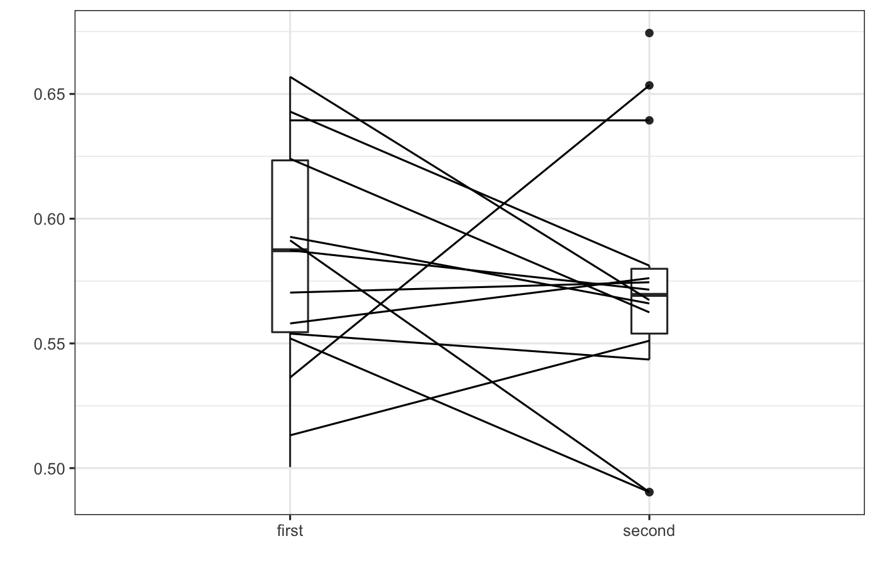

**Figure 1:** Paired t-test of the original (first) male mate colouration compared to the second male mate (N = 30).

Figure 1 shows that the paired t-test analysis indicated that there was no significant difference between the original male mate’s colouration and the new male mate when females participated in multiple mate pairings (Df = 12, P-value = 0.2585).

**Figure 2:** Paired t-test of the original (first) female mate colouration compared to the second female mate (N = 21).

Figure 2 shows that the paired t-test analysis indicated that there was no significant difference between the original female mate’s colouration and the new female mate when males participated in multiple mate pairings (Df = 14, P-value = 0.3052).

**Discussion:**

Mountain bluebirds were thought to be socially monogamous, however through extensive data collection and analysis, it has been shown that this is not the case all the time. Mating pairs can fail and lead to divorce for multiple reasons, but an emerging hypothesis known as the Better Option Hypothesis has shown that there could be a single driving force leading to divorce. That mating pairs will divorce because a single mate will leave their current partner for one that demonstrates they have better qualities and can provide better offspring (Choudhury, 1995; Wilson et. al, 2021).

When analyzing an extensive data set pertaining to mountain bluebirds that have had multiple mates, we were able to see if the Better Option Hypothesis was being demonstrated in terms of colouration. We predicted that if an individual was to have multiple mates, then they would form a pair with a mate that was more brightly coloured than the previous one. This would be due to the fact that a more brightly coloured mate demonstrates better qualities and would provide better offspring.

After performing an ANOVA statistical test which looked at if a year effect was present, it was found that there was no significant difference between the mates and the year (Males: p > 0.05; Females: p >0.05). A paired t-test was then performed on both the male and female mates separately, looking at if there was a difference in colouration between the first mate and the second mate. It was found that there was no significant difference between the mates regarding colouration (Males: p>0.05; Females: p > 0.05).

The findings from this study indicates that an individual did not divorce their first mate and seek a new mate that was more brightly coloured. Colouration was not the driving factor causing a new mate pairing in bluebirds. There must be more factors that play a larger role in mate choice for mountain bluebirds.

Future research could look at the environment the nests were in, to see if that played a factor in whether or not bluebirds would divorce and seek a new mate. Other physical features such as wing or tail length could be further researched to see if they also played a role in divorce occurrences.

**References:**

Choudhury, Sharmila. “Divorce in birds: a review of the hypotheses.” *Animal Behaviour* vol 50, Issue 2, Pages 413-429. August 1995. <https://doi.org/10.1006/anbe.1995.0256>

Mercier, Guillaume et al. “Influence of reproductive output on divorce rates in polar seabirds.” *Ecology and evolution* vol. 11,19 Pages 12989-13000. 12 Sep. 2021, doi:10.1002/ece3.7775

Ramsay, Scott et al. “Divorce and extrapair mating in female black-capped chickadees (Parus atricapillus): separate strategies with a common target.” *Behavioural Ecology* vol. 49, Pages 18-23. 4 September. 2000. <https://link.springer.com/content/pdf/10.1007/s002650000270.pdf>

Vicente García- Navas, Juan José Sanz, Females call the shots: breeding dispersal and divorce in blue tits, Behavioral Ecology, Volume 22, Issue 5, Pages 932–939,  September-October 2011, <https://doi.org/10.1093/beheco/arr067>

Wilson, Kerianne et. al, “Divorce rate varies with fluidity of passerine social environment.” *Animal Behaviour* vol 183 Pages 51-60. 26 Nov 2021. <https://doi.org/10.1016/j.anbehav.2021.10.018>